**Health Management System: A comparative study**

**L.C. Lebelo**

**34687602**

Research proposal for the research project submitted in *partial* fulfillment of the requirements for the degree BSc Honors in Computer Science and Information Technology in at the North-West University

Supervisor: Mr. Kobus Van Aswegen

Date of submission: 16 May 2023

Table of Contents

1 Introduction 1

2 Paradigms 2

2.1.1 Positivism 2

2.1.2 Interpretivism 3

2.1.3 Post positivism 4

2.1.4 Critical Social theory 5

3 Research Methodology 6

3.1.1 The cycle of relevance 7

3.1.2 The cycle of design 7

3.1.3 The cycle of rigor 7

3.1.4 Research problems in Design Science Research 10

4 Research Methods 11

4.1 Case Study 11

4.2 Action Research 12

4.3 Survey 13

4.4 Modelling 13

4.5 Prototyping 13

5 Research design 15

6 Conclusion 17

7 References 18

List of Figures

Figure 1: Relevance and Cycle of Rigor in Design Science Research (Dresch, Larceda et al. 2015). 8

Figure 2: Criteria for conducting Design Science Research (Henver, March et al. 2004). 9

RESEARCH Methodology

# Introduction

The focus of the research is the implementation and adoption of health management systems in healthcare organizations. The study aims to investigate the challenges and opportunities facing healthcare organizations in adopting health management systems, the impact of these systems on patient care and outcomes, and the factors that influence their adoption and use. The research aims to provide insights and recommendations that can guide healthcare organizations in their decision-making processes and improve the quality of patient care and outcomes in healthcare. The problem statement highlights the challenges faced in managing patient health information efficiently and securely in the healthcare industry and the need for an efficient and secure electronic health management system that can integrate with existing healthcare systems to improve patient care and outcomes. The health management system will consist of the following features: appointment setting, storage of data and the ability to share data amongst health organisations. We will address this in this chapter by conducting research and choosing the appropriate paradigm for this research, the suitable methodology the aligns with the paradigm chosen, the appropriate research methods and the research design for this research.

This chapter will cover several key components of research, including paradigms, research methods, research methodology, research methods, and research design. It will explore different paradigms or worldviews that underlie research, including positivism, interpretivism, and critical theory. The chapter will also delve into the different research methods available, such as surveys, case studies, experiments, and ethnography, and explain their advantages and disadvantages. The research methodology will be discussed, including how to formulate research questions, collect and analyse data, and interpret the results. Finally, the chapter will explore research design, including how to select the appropriate design for a study, such as cross-sectional, longitudinal, or mixed-methods design.

At the end of this chapter, we will have a better understanding of the different paradigms, research methods, research methodology, research methods, and research design used in research studies. The chapter will provide an overview of each concept and how they relate to each other in the research process. Additionally, the chapter will discuss the importance of choosing the appropriate paradigm, methodology, methods, and design for a specific research study and how they can impact the findings and outcomes of the study. By the end of the chapter, the reader should have a clearer understanding of these concepts and be able to apply them to their own research studies.

# Paradigms

## Positivism

Positivism is a philosophical school that gained prominence in the early 19th century thanks to the writings of Auguste Comte, a French philosopher (Rehman and Alharthi 2016). Positivism posits that the objective reality exists independently of human observation or perception. In terms of ontology, positivists adopt a realist stance because positivists seek to comprehend the social realm using methods and principles that resemble those used in the study of the natural realm (Rehman and Alharthi 2016). The epistemological viewpoint of positivists is grounded in objectivism because researchers strive to maintain objectivity and neutrality as they investigate phenomena that exist independently of their own existence and activities, without altering or interfering with what they are observing. This paradigm emphasizes the use of scientific methods and the collection of empirical data to establish objective knowledge. Positivism holds that reality can be objectively measured and understood using quantitative methods, and that the goal of research is to discover the objective truths that underlie the phenomena being studied. The methodology of positivism places a significant emphasis on experimentation, where the researcher formulates hypotheses in the form of propositions or questions that aim to establish causal relationships between different phenomena (Rehman and Alharthi 2016).

This paradigm is not appropriate for this research because the positivism paradigm is focused on quantitative data and objective measurement, which may not be sufficient for understanding complex healthcare systems and the interactions between stakeholders such as healthcare providers and patients.

## Interpretivism

Interpretivism is a perspective that emerged as an alternative to the dominant approach of positivism (Rehman and Alharthi 2016). Interpretivism posits that there is no single objective reality that exists independently of our perceptions and experiences (Rehman and Alharthi 2016), and therefore rejects the idea that there is a universally verifiable truth that can be discovered through scientific inquiry. Instead, interpretivism emphasizes the importance of subjective meanings and interpretations in shaping our understanding of the world. An interpretive ontology rejects the idea of a foundation for knowledge or reality because it rejects the idea of having a set of permanent and universally accepted standards for establishing truth (Rehman and Alharthi 2016). Interpretivists believe that social reality is shaped by the meanings, values, and beliefs of individuals and groups, and that these meanings must be understood in their own context. Interpretive epistemology is based on subjectivity because observers cannot have direct access to external reality without their own perspectives, ideas, and experiences affecting their perception(Rehman and Alharthi 2016). Therefore, any observation of the world is influenced by the observer's own worldview, concepts, and background knowledge. The aim of interpretive research is not to uncover objective, impartial knowledge or absolute truths that are applicable across all contexts, but rather to comprehend how individuals interpret and make sense of the social phenomena they encounter. The interpretive paradigm has faced criticism for several reasons. One criticism is that it is perceived as "soft," lacking the ability to generate theories that can be applied to broader populations, more over the involvement of the researcher with study participants can compromise objectivity, leading to potential bias (Rehman and Alharthi 2016). Interpretive methodology emphasizes the importance of understanding social phenomena from the perspective of the participants themselves, rather than solely relying on the researcher's interpretation (Rehman and Alharthi 2016). In other words, the focus is on gaining insight into how individuals experience and interpret their social world, rather than imposing preconceived notions or assumptions onto their experiences.

This paradigm will work for this research because this paradigm is useful for understanding the social context in which an artifact will be used and the artefact that will be developed is for medical purposes and there will not be a need to conduct interviews nor observations for the development of the artefact. Health management systems involve intricate social, cultural, and organizational dynamics. Interpretivism allows for the exploration and understanding of the complex and contextual nature of these systems. It enables this study to delve into the meanings, experiences, and perspectives of individuals involved in the use and implementation of health management systems.

## Post positivism

The critique of the positivist paradigm resulted in the development of post-positivism, which combines elements of both positivist and interpretivist paradigms thus post-positivism is a response to the limitations of the positivist paradigm, which aims to overcome its weaknesses (Rehman and Alharthi 2016). Post-positivism holds a critical realist ontological position, which means that it assumes the existence of an objective reality that is independent of the observer, however, due to the intricate nature of social phenomena, this reality can only be imperfectly understood (Rehman and Alharthi 2016). Additionally, post-positivism acknowledges that the researcher's own beliefs and values may influence the observations made (Rehman and Alharthi 2016). Post-positivism shares some of the basic assumptions of positivism, such as the importance of empirical evidence and scientific methods. a hypothesis is put forward and its validity is then assessed through statistical analysis. The outcome of the statistical analysis determines whether the hypothesis is accepted or rejected. the aim of scientific inquiry is to achieve various goals, such as quantifying and regulating phenomena, making predictions about future outcomes, establishing general principles or laws, and identifying causal relationships between variables (Rehman and Alharthi 2016). The act of using numerical measures to depict and examine aspects of social existence aligns with a positivist approach to knowledge (epistemology) because this approach presumes that these aspects remain consistent over time and contexts, that specific features can be isolated and viewed as variables - entities that can take on different values (Rehman and Alharthi 2016). It recognizes the limitations and subjectivity of these methods.

This paradigm will not work for this research because it does not provide clear guidance for the development process of the Health Learning Management System artefact, and it is more focused on the subjective experiences and social constructions of the Health Learning Management System rather than on creating an artefact that can reliably be used in a clinical setting.

## Critical Social theory

Critical theory emerged from the writings of a group of authors in the 20th century who were associated with the Institute of Social Research at the University of Frankfurt, and this is why they are commonly referred to as the Frankfurt School (Rehman and Alharthi 2016). Critical social theory is a philosophical approach that focuses on the critique of society and its structures to bring about social change. It is an interdisciplinary field that draws from various social sciences, including sociology, philosophy, and political science. Critical theorists adopt a position of historical realism when it comes to their ontological perspective because The assumption is made that a concrete reality exists, but it is moulded by a combination of cultural, political, ethnic, gender, and religious influences that interplay with each other to produce a complex societal system (Rehman and Alharthi 2016). Critical theory has a subjective epistemological approach, as it assumes that the researcher cannot investigate an object without influencing it thus Critical educational researchers aim to be aware of their own underlying assumptions about knowledge and its acquisition, and to articulate these assumptions clearly when conducting their investigations (Rehman and Alharthi 2016). This ensures that everyone involved in the research is aware of the researchers' epistemological and political perspectives and prevents any confusion or misunderstandings about the researchers' biases or values. The primary goal of critical educational research is not limited to providing an explanation or comprehension of the workings of society but rather to effect change in it (Rehman and Alharthi 2016). In other words, critical educational research aims to go beyond a passive understanding of society and instead strives to actively transform it. Rather than producing knowledge that merely describes and reinforces the current state of society, critical researchers aim to uncover the underlying beliefs and behaviours that restrict individual freedom (Rehman and Alharthi 2016). The interpretive and positivist approaches to research are criticized because they are seen as being deeply embedded in the prevailing ideology, without any interest in transforming society, and lacking any intention to promote liberation (Rehman and Alharthi 2016). The critical methodology involves a back-and-forth conversation that aims to promote change in the perspective of the subjects regarding the social systems that deprive them of their intellectual and social needs. The investigator engages in dialogue with the subjects to achieve this objective (Rehman and Alharthi 2016).

This paradigm will not be appropriate for this study because the focus of this study is more practical and technical and may not require an in-depth analysis of power dynamics and social justice issues.

# Research Methodology

Design Science Research will be used for this research because Design science research methodology provides a structured approach to developing an artefact that is grounded in empirical evidence and focused on addressing a specific problem or need which in this case is the quality of patient care and outcomes in healthcare. And since critical social theory will be used as a paradigm, combining these two approaches create an opportunity to develop a health learning management system that is grounded in empirical evidence and best practices, while also being informed by a critical perspective that considers the broader social context in which the system will be used. This can help to ensure that the system is effective in achieving its goals, while also being sensitive to the needs and preferences of stakeholders. The concept of Design Science Research (DSR) involves solving problems and improving human understanding by creating innovative artefacts (Brocke et al. 2020). Design science research involves constructing or evaluating artifacts, which can be classified as constructs, models, methods, and instantiations (March and Smith 1995). The resulting artifacts may lead to the improvement of theories (Henver and Chatterjee 2010).These artifacts are the output of design science research. A design science research project is primarily concerned with the creation and evaluation of a modern design rather than the generation of new knowledge (Gregory 2010). In other words, the focus of a design science research project is on the practical application and testing of a modern design, rather than the theoretical exploration and discovery of new knowledge. In a design research project, there are typically three cycles of design science research: the cycle of relevance, the cycle of design, and the cycle of rigor (Henver and Chatterjee 2010). This means that throughout the project, researchers engage in a process of identifying the relevant problem or issue, designing potential solutions, and rigorously evaluating the effectiveness of those solutions. Each cycle informs and builds upon the others, leading to a more refined and effective outcome.

## The cycle of relevance

The underlying motivation is to introduce innovative solutions that can improve the existing situation thus the relevance cycle is the starting point for design science research, which begins with an application context. This context not only provides the necessary requirements for the research, such as identifying a problem that needs to be addressed, but it also outlines the criteria for evaluating the research results to determine if they meet the desired outcomes (Henver 2007).

## The cycle of design

The fundamental component of any design science research project is the internal design cycle, which is integral to the entire process of designing, creating, or enhancing something. This cycle of designing involves creating multiple options and then assessing each one to determine which one meets the necessary standards or expectations (Henver 2007). This cycle continues until a design is found that meets all the necessary requirements and is deemed satisfactory. According to (Henver 2007) it is crucial to maintain an equilibrium between the resources utilized in creating and assessing the developing design during the design cycle.

## The cycle of rigor

The rigor cycle involves incorporating existing knowledge into a research project to ensure its originality and novelty (Henver 2007). Researchers must put in the effort to produce designs that make a unique and significant contribution to the field, rather than simply relying on established processes thus In design science research, the rigor of the research is dependent on the researcher's ability to choose and use suitable theories and methods to create and assess the artefact (Henver 2007).

In general, the process of design science research comprises three stages: identifying a problem that is applicable and significant, creating an IT artefact to address the issue, and assessing its value before and after implementation with the intension to achieve the primary objective of design science research which is to identify and solve real-world problems that are practical and relevant (Henver and Chatterjee 2010).

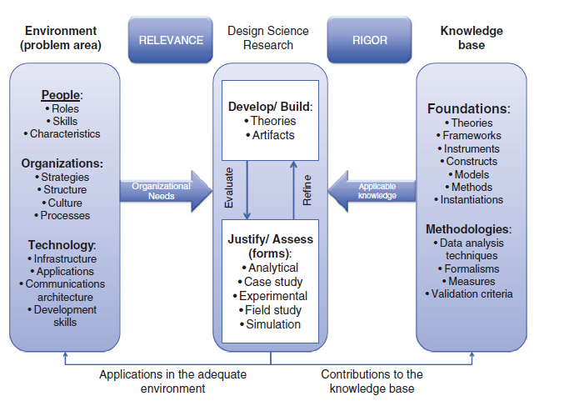

Figure 1: Relevance and Cycle of Rigor in Design Science Research (Dresch et al. 2015).

The term "environment" in Figure 1 pertains to the specific setting where the researcher can observe and obtain the phenomenon of interest related to the problem being studied (Henver et al. 2004).

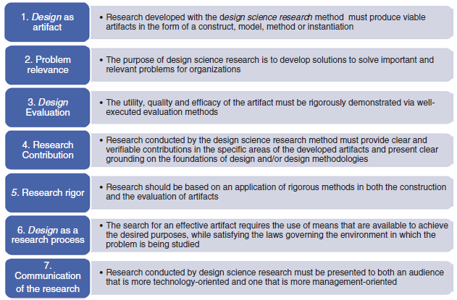

Figure 2: Criteria for conducting Design Science Research (Henver et al. 2004).

The criteria used in design science research are crucial because this type of research involves creating a new artifact (criterion 1) that addresses a specific problem (criterion 2) (Henver et al. 2004). The usefulness of the artifact should be explained, and it must be adequately evaluated (criterion 3) (Henver et al. 2004). It is important to clarify the research contributions for both professionals who aim to solve organizational problems and the academic community that seeks to advance knowledge in the field (criterion 4) (Henver et al. 2004). In order to ensure the validity and reliability of the research, investigations should be conducted with enough rigor to demonstrate that the constructed artifact is appropriate for its intended use and that it meets the criteria for its development (criterion 5) (Henver et al. 2004). The researcher must also conduct research to understand the problem and explore potential problem-solving methods in order to construct or evaluate the artifact (criterion 6) (Henver et al. 2004). Finally, the research results should be effectively communicated to all interested parties (criterion 7) (Henver et al. 2004).

## Research problems in Design Science Research

In design science, there are two components: design and investigation, which address two distinct types of research problems. The first component, design, deals with design problems, while the second component, investigation, deals with knowledge questions in design science (Wieringa 2014).

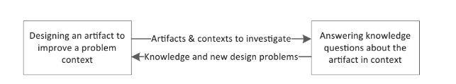

Figure 3: Design Science iterates over two problem solving activities (Wieringa 2014).

When faced with design problems, it is necessary to bring about a change in the real world, this requires an examination of the goals of stakeholders, whether they are hypothetical or actual (Wieringa 2014). In contrast to design problems, knowledge questions do not necessitate a modification in the world but rather seek information about the existing state of the world and the answer to a knowledge question takes the form of a proposition, and it is assumed that there is only one correct answer when attempting to address a knowledge question (Wieringa 2014).

## Qualitative study

As part of my methodology, a qualitative study will be conducted to address the following questions:

1. What is the relationship between the implementation of a health management system and patient outcomes?
2. How do different health management systems compare in terms of efficiency and cost-effectiveness?
3. What are the factors that influence the adoption and implementation of health management systems in healthcare organizations?
4. What is the impact of health management systems on healthcare provider job satisfaction and burnout?

## Testing the artefact as part of ensuring rigor and validity

Rigor in testing involves conducting comprehensive and well-designed testing procedures to ensure that the system performs as intended. Validity in testing refers to the extent to which the testing process measures what it is intended to measure and produces accurate and dependable results. The following are ways that I will use to test my health management system artifact:

1. **Functional testing**: This involves testing the system's features and functionalities to ensure that they work as intended. This can be done by creating test scenarios and scripts and executing them to verify that the system meets the requirements.
2. **Performance testing**: This involves testing the system's ability to handle many users and data without compromising its performance. This can be done by simulating a high workload and monitoring the system's response time and resource utilization.
3. **Security testing:** This involves testing the system's security features to ensure that patient data is protected from unauthorized access, modification, or theft. This can be done by conducting vulnerability assessments, penetration testing, and other security testing techniques.
4. **Usability testing**: This involves testing the system's user interface and user experience to ensure that it is user-friendly and easy to use. This can be done by conducting user surveys, interviews, and usability tests to gather feedback from users and identify areas for improvement.
5. **Compliance testing**: This involves testing the system's compliance with regulatory standards and requirements, such as POPI Act.

# Research Methods

Defining and justifying the research method is crucial because it ensures that the investigation will address the research problem effectively, moreover, using an appropriate research method enhances the credibility of the investigation among the scientific community, indicating that the research work is trustworthy and valuable for the field(Dresch et al. 2015). In other words, selecting an appropriate research method is significant in providing a reliable and valid answer to the research problem, which, in turn, increases the likelihood of the research work being accepted and recognized by the scientific community. Out of numerous methods available, five have been chosen as the most significant, and these methods will now be explained (Dresch et al. 2015).

## Case Study

According to (Yin 2013) a case study is an empirical investigation that aims to enhance our comprehension of a complex and contemporary phenomenon in its genuine context. The case study research method is well-suited for examining intricate issues within their specific context because it is particularly effective for exploring problems that are multifaceted and occur in real-world settings (Dubé and Paré 2003). Case studies are typically conducted using various data-gathering techniques such as interviews, questionnaires, observations, and other methods (Eisenhardt 1989). These methods are used to collect evidence that supports the researcher's investigation, and the evidence gathered may be either quantitative or qualitative in nature. The primary objectives of conducting a case study, which include: (I) providing a detailed account of a particular phenomenon; (II) testing an existing theory; and (III) developing a novel theory were identified by (Eisenhardt 1989). The connection between case studies and the scientific method can be attributed to two main factors, firstly, case studies typically commence with the observation and analysis of real-life phenomena and secondly, the scientific method involves the creation of theories, which is also a primary objective of case studies (Eisenhardt 1989).

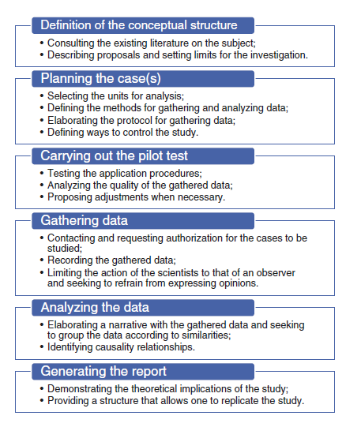

Figure 4: Activities in a case study (Miguel 2007).

## Action Research

Action research aims to identify and resolve problems within a specific system by producing knowledge that can be applied both in practice and theory(Dresch et al. 2015). The goal of action research is to provide practical solutions to issues that arise within a system while also generating theoretical insights that can inform future research (Dresch et al. 2015). Through the cyclical process of problem identification, solution design, implementation, and evaluation, action research seeks to improve the overall functioning of a system by producing actionable insights that can be used to make informed decisions (Dresch et al. 2015). If the method of analysis used involves a participatory approach, it presupposes that the researcher works closely with the members of the system being studied and that there is mutual collaboration and engagement between them (Morandi et al. 2013). In Action Research, the researcher may have dual rules, firstly, the researcher may be involved as participants in implementing a system and secondly, the researcher may also seek to evaluate an intervention technique while simultaneously serving as a participant (Benbasat et al. 1987). Action Research is a research method based on empirical evidence and requires a qualitative approach (Dresch et al. 2015). This approach involves working collaboratively with stakeholders to identify problems, design solutions, and evaluate their effectiveness (Dresch et al. 2015). At the end of the study, the results of the research should be compared with the existing theories (Dresch et al. 2015). It is also necessary to implement the proposed solutions to assess their effectiveness (Dresch et al. 2015). In contrast to a study case or action research, survey research uses a quantitative approach (Dresch et al. 2015).

## Survey

A survey-based study aims to generate knowledge in a particular area by collecting data or information to evaluate the behaviour of individuals and/or their surroundings(Aline Dresch 2015). The investigation is focused on obtaining information to analyse the behaviour of people and the environment they interact with (Miguel 2007). Additionally, surveys are often utilized to collect dependable data that can withstand rigorous statistical analysis (Dresch et al. 2015). The objective of such studies is to produce trustworthy and accurate results that can be used to make informed decisions (Dresch et al. 2015).

## Modelling

The use of modelling as a research method can help researchers to gain a deeper understanding of complex problems (Dresch et al. 2015). A model is a simplified version of reality that enables investigators to more easily grasp and analyse the phenomena they are studying (Neto and Pureza 2012). By creating and analysing these models, researchers can improve their understanding of the environment and the various factors that influence it (Neto and Pureza 2012). Ultimately, modelling can be a valuable tool for researchers seeking to explore and address complex problems.

## Prototyping

Prototyping involves a methodical approach to developing and evaluating a new product design concept (Camburn et al. 2015). The goal is to determine the feasibility of the concept and improve the design details of pre-production models through testing and feedback (Camburn et al. 2015). Research has shown that the way in which prototyping is approached can have a significant effect on the outcomes, both in the short and long term (Camburn et al. 2015). This suggests that the choice of prototyping approach can be an important factor in determining the success of a project.

To effectively address the research questions and develop a viable solution for the research problem, this study will utilize action research and prototyping research methods. The choice of these research methods is informed using qualitative data in answering the research questions and in the development of an artifact as a solution to the research problem. The combination of these methods will enable a comprehensive analysis of the research problem, informed decision-making, and ultimately, the production of a useful and effective solution. The following will be the steps used to choose the research method:

* Identify your research question: Clearly articulate the research question you want to answer. This will help you identify the type of data you need to collect and the appropriate research method to use.
* Determine the scope: Define the scope and focus of my research, including the population you want to study, the time frame, and the setting.
* Evaluate available resources: Consider the resources available, including time, budget, and access to participants, equipment, and technology.
* Choose an appropriate research design: Select a research design that aligns with your research question, scope, and available resources. Options include experimental research, surveys, case studies, and others.
* Determine data collection methods: Choose data collection methods that fit with your research design, such as interviews, questionnaires, focus groups, or observations.
* Consider ethical concerns: Identify any ethical considerations related to your research and ensure that your research methods are following ethical standards.

# Research design

The design of a research study refers to the structure or system of techniques and approaches employed to gather and analyse data related to specific variables identified in a research question (Ranganathan and Aggarwal 2018). The design cycle consists of the following stages:

1. **Define the problem:** The lack of standardized electronic health learning management system across the industry has resulted in the lack of interoperability and compatibility among different healthcare systems, leading to suboptimal patient outcomes and increased healthcare costs. An efficient and secure electronic health learning management system is needed to integrate with existing healthcare systems to improve patient care and outcomes.
2. **Conduct research**: A literature review will be conducted to gather more information about the existing Health learning management systems and observing how they work.
3. **Brainstorm**: From the information gathered from the previous stage, brainstorming of solutions to breach the gap of the existing Health Management System that will solve the research problem will be done.
4. **Prototype**: The best Ideas or solutions from the Ideate stages will be used to develop an artefact or prototype
5. **Test**: Test if whether the artefact can solve the research problem efficiently and identify areas of improvement
6. **Iterate**: Based on the results from testing, the design is refined, and the cycle begins again with the revised design being evaluated and further refined until a satisfactory solution is achieved.

# Conclusion

In conclusion, this chapter has provided an overview of research paradigms, research methodology, research methods, and research design. This chapter has highlighted the different research paradigms including positivism, interpretivism, post positivism and critical theory, research methodology including qualitative method. This chapter also provided an overview of various research methods, including case study, surveys, action research, modelling and prototyping and selecting the appropriate research design to address the research questions and objectives. The next chapter will provide an overview of the literature study of this study.

# References

Adil Abdul Rehman, K. A., 2016. An Introduction to Research Paradigms. *International Journal of Educational Investigation,* 3(8), pp. 51-59.

Alan Henver, S. C., 2010. *Design Research in Information Systems.* New York: Springer.

Aline Dresch, D. P. L. J. A. V. A. J., 2015. *Design Science Research: A Method for Science and Technology.* New York: Springer.

Anon., 2022. *northoasss.* [Online]   
Available at: https://www.northpass.com/healthcare-lms  
[Accessed 15 March 2023].

Bose, R., 2003. Knowledge management-enabled health care management. *Expert Systems with Applications,* Issue 24, pp. 59-71.

Bradley Camburn, B. D. T. G. C. H. M. G. D. J. R. C. K. O. K. W., 2015. A Systematic Method for Design Prototyping. *Journal of Mechanical Design,* Volume 137.

Cauchick Miguel, P. A., 2007. Case study in production engineering. *Structure and recommendations for conducting one,* I(17), pp. 216-299.

Dubé L., P. G., 2003. Rigor in information systems positivist case research. *current practices, tre. MIS Quarterly,* IV(27), pp. 597-635.

Eisenhardt, K., 1989. Building theories from case study research. *Academy of Management Review,* IV(14), pp. 532-550.

Gregory, R. W., 2010. *Design Science Research And The Grounded Theory Method: Characteristics, Differences, and Complementary Uses.* Pretoria, South Africa, s.n.

Hevner, A. M. S. P. J. R. S., 2004. Design Science in Information Systems Research. *MIS Quaterly,* I(28), pp. 75-105.

Hevner, A. R., 200. A Three Cycle View of Design Science Research. *Scandinavian Journal of Information Systems,* 19(2), pp. 3-6.

Izak Benbasat, D. K. G. M. M., 1987. The Case Research Strategy in Studies of Information Systems. *MIS Quarterly,* III(11), pp. 369-386.

Jan vom Brocke, A. H. A. M., 2020. Introduction to Design Science Research. *Research Gate.*

March S.T., S. G., 1995. Design and natural science research on information technology. *Decision Support Systems,* Issue 15, pp. 251-266.

Maria Isabel Wolf Motta Morandi, L. H. R. D. P. L. I. P., 2013. Foreseeing Iron Ore Prices Using System Thinking and Scenario Planning. *Systems Practice and Action Research,* Issue 27, pp. 287-306.

Morabito Neto, R. &. P. V., 2012. *Modelagem e Simulação [Modeling and Simulation]. Modelagem e Simulação [Modeling and Simulation]..* 2nd ed. Rio de Janeiro: Ed. Campus.

Priya Ranganathan, R. A., 2018. *National Library of Medicine: National Center for Biotechnology Information..* [Online]   
Available at: https://www.ncbi.nlm.nih.gov/pmc/articles/PMC6176693/#:~:text=Research%20study%20design%20is%20a,in%20a%20particular%20research%20problem.  
[Accessed 10 April 2023].

Wieringa, R. J., 2014. *Design Science Methodology.* Berlin Heidelberg: Springer.

Yin, R., 2013. *Case study research: Design and methods.* 5th ed. Newbury Park, CA: Sage Publications Inc..